Reeksamen 2020

a)
P:
$$\max{2x_{1}+3x_{2}-5x_{3}}$$
$$s.t\left(\begin{matrix}1 & 1 & -1 \\ -1 & 0 & -1\end{matrix}\right)x≤\left(\begin{aligned}2 \\ -2\end{aligned}\right),x≥0$$
Omskrevet til standardform
$$\max{2x_{1}+3x_{2}-5x_{3}}$$
$$s.t\left(\begin{matrix}1 & 1 & -1 & 1 & 0 \\ -1 & 0 & -1 & 0 & 1\end{matrix}\right)x=\left(\begin{aligned}2 \\ -2\end{aligned}\right),x≥0$$
$$c=(\begin{matrix}2 & 3 & -5 & 0 & 0\end{matrix})$$
$$b=\left(\begin{aligned}2 \\ -2\end{aligned}\right)$$
D:
$$\min{{2·y}_{1}-2·y_{2}}$$
$$s.t$$
$$\left(\begin{matrix}1 & -1 \\ 1 & 0 \\ -1 & -1 \\ 1 & 0 \\ 0 & 1\end{matrix}\right)y≥\left(\begin{aligned}2 \\ 3 \\ -5 \\ 0 \\ 0\end{aligned}\right)$$
b)
vi tjekker primal og dual brugbarhed af hver basis
1,2
$$\overline{x}={\left(\begin{matrix}1 & 1 \\ -1 & 0\end{matrix}\right)}^{-1}\left(\begin{aligned}2 \\ -2\end{aligned}\right)=\left(\begin{matrix}2 \\ 0\end{matrix}\right)≥0$$
$$\overline{y}=\left(\begin{matrix}2 & 3\end{matrix}\right){\left(\begin{matrix}1 & 1 \\ -1 & 0\end{matrix}\right)}^{-1}=\left(\begin{matrix}3 & 1\end{matrix}\right)$$
$$\left(\begin{matrix}1 & -1 \\ 1 & 0 \\ -1 & -1 \\ 1 & 0 \\ 0 & 1\end{matrix}\right)\left(\begin{aligned}3 \\ 1\end{aligned}\right)=\left(\begin{matrix}2 \\ 3 \\ -4 \\ 3 \\ 1\end{matrix}\right)≥\left(\begin{aligned}2 \\ 3 \\ -5 \\ 0 \\ 0\end{aligned}\right)$$
Da er basis dualt og primalt brugbar og derved optimal
1,3
$${\left(\begin{matrix}1 & -1 \\ -1 & -1\end{matrix}\right)}^{-1}\left(\begin{aligned}2 \\ -2\end{aligned}\right)=\left(\begin{matrix}2 \\ 0\end{matrix}\right)≥0$$
$$\left(\begin{matrix}2 & -5\end{matrix}\right){\left(\begin{matrix}1 & -1 \\ -1 & -1\end{matrix}\right)}^{-1}=\left(\begin{matrix}\frac{7}{2} & \frac{3}{2}\end{matrix}\right)$$
$$\left(\begin{matrix}1 & -1 \\ 1 & 0 \\ -1 & -1 \\ 1 & 0 \\ 0 & 1\end{matrix}\right)\left(\begin{aligned}\frac{7}{2} \\ \frac{3}{2}\end{aligned}\right)=\left(\begin{matrix}2 \\ \frac{7}{2} \\ -5 \\ \frac{7}{2} \\ \frac{3}{2}\end{matrix}\right)≥\left(\begin{aligned}2 \\ 3 \\ -5 \\ 0 \\ 0\end{aligned}\right)$$
Da er løsningen primalt og dualt brugbar og derved optimal
1,4
$${\left(\begin{matrix}1 & 1 \\ -1 & 0\end{matrix}\right)}^{-1}\left(\begin{aligned}2 \\ -2\end{aligned}\right)=\left(\begin{matrix}2 \\ 0\end{matrix}\right)≥0$$
Er primalt brugbar
$$\left(\begin{matrix}2 & 0\end{matrix}\right){\left(\begin{matrix}1 & 1 \\ -1 & 0\end{matrix}\right)}^{-1}=\left(\begin{matrix}0 & -2\end{matrix}\right)$$
$$\left(\begin{matrix}1 & -1 \\ 1 & 0 \\ -1 & -1 \\ 1 & 0 \\ 0 & 1\end{matrix}\right)\left(\begin{aligned}0 \\ -2\end{aligned}\right)=\left(\begin{matrix}2 \\ 0 \\ 2 \\ 0 \\ -2\end{matrix}\right)$$
Ikke dualtbrugbar

1,5
$${\left(\begin{matrix}1 & 0 \\ -1 & 1\end{matrix}\right)}^{-1}\left(\begin{aligned}2 \\ -2\end{aligned}\right)=\left(\begin{matrix}2 \\ 0\end{matrix}\right)≥0$$
Da primalt brugbar
$$\left(\begin{matrix}2 & 0\end{matrix}\right){\left(\begin{matrix}1 & 0 \\ -1 & 1\end{matrix}\right)}^{-1}=\left(\begin{matrix}2 & 0\end{matrix}\right)$$
$$\left(\begin{matrix}2 & 0\end{matrix}\right)\left(\begin{matrix}1 & 1 & -1 & 1 & 0 \\ -1 & 0 & -1 & 0 & 1\end{matrix}\right)-\left(\begin{matrix}2 & 3 & -5 & 0 & 0\end{matrix}\right)=\left(\begin{matrix}0 & -1 & 3 & 2 & 0\end{matrix}\right)$$
Ikke dualt brugbar

2,3
$${\left(\begin{matrix}1 & -1 \\ 0 & -1\end{matrix}\right)}^{-1}\left(\begin{aligned}2 \\ -2\end{aligned}\right)=\left(\begin{matrix}4 \\ 2\end{matrix}\right)≥0$$
Da primalt brugbar
$$\left(\begin{matrix}3 & -5\end{matrix}\right){\left(\begin{matrix}1 & -1 \\ 0 & -1\end{matrix}\right)}^{-1}=\left(\begin{matrix}3 & 2\end{matrix}\right)$$
$$\left(\begin{matrix}3 & 2\end{matrix}\right)\left(\begin{matrix}1 & 1 & -1 & 1 & 0 \\ -1 & 0 & -1 & 0 & 1\end{matrix}\right)-\left(\begin{matrix}2 & 3 & -5 & 0 & 0\end{matrix}\right)=\left(\begin{matrix}-1 & 0 & 0 & 3 & 2\end{matrix}\right)$$
Ikke dualt brugbar

2,4
A_B ikke invertibel da ikke basis

2,5
$${\left(\begin{matrix}1 & 0 \\ 0 & 1\end{matrix}\right)}^{-1}\left(\begin{aligned}2 \\ -2\end{aligned}\right)=\left(\begin{matrix}2 \\ -2\end{matrix}\right)$$
Ikke primalt brugbar
$$\left(\begin{matrix}5 & 0\end{matrix}\right)\left(\begin{matrix}1 & 1 & -1 & 1 & 0 \\ -1 & 0 & -1 & 0 & 1\end{matrix}\right)-\left(\begin{matrix}2 & 3 & -5 & 0 & 0\end{matrix}\right)=\left(\begin{matrix}3 & 2 & 0 & 5 & 0\end{matrix}\right)≥0$$
Er dualt brugbar
3,4
$${\left(\begin{matrix}-1 & 1 \\ -1 & 0\end{matrix}\right)}^{-1}\left(\begin{aligned}2 \\ -2\end{aligned}\right)=\left(\begin{matrix}2 \\ 4\end{matrix}\right)≥0$$
Er primalt brugbar
$$\left(\begin{matrix}-5 & 0\end{matrix}\right){\left(\begin{matrix}-1 & 1 \\ -1 & 0\end{matrix}\right)}^{-1}=\left(\begin{matrix}0 & 5\end{matrix}\right)$$
$$\left(\begin{matrix}0 & 5\end{matrix}\right)\left(\begin{matrix}1 & 1 & -1 & 1 & 0 \\ -1 & 0 & -1 & 0 & 1\end{matrix}\right)-\left(\begin{matrix}2 & 3 & -5 & 0 & 0\end{matrix}\right)=\left(\begin{matrix}-7 & -3 & 0 & 0 & 5\end{matrix}\right)$$
Ikke dualt brugbar

3,5
$${\left(\begin{matrix}-1 & 0 \\ -1 & 1\end{matrix}\right)}^{-1}\left(\begin{aligned}2 \\ -2\end{aligned}\right)=\left(\begin{matrix}-2 \\ -4\end{matrix}\right)$$
Ikke primalt brugbar
$$\left(\begin{matrix}-5 & 0\end{matrix}\right){\left(\begin{matrix}-1 & 0 \\ -1 & 1\end{matrix}\right)}^{-1}=\left(\begin{matrix}5 & 0\end{matrix}\right)$$
$$\left(\begin{matrix}5 & 0\end{matrix}\right)\left(\begin{matrix}1 & 1 & -1 & 1 & 0 \\ -1 & 0 & -1 & 0 & 1\end{matrix}\right)-\left(\begin{matrix}2 & 3 & -5 & 0 & 0\end{matrix}\right)=\left(\begin{matrix}3 & 2 & 0 & 5 & 0\end{matrix}\right)≥0$$
Da dualt brugbar

4,5
$${\left(\begin{matrix}1 & 0 \\ 0 & 1\end{matrix}\right)}^{-1}\left(\begin{aligned}2 \\ -2\end{aligned}\right)=\left(\begin{matrix}2 \\ -2\end{matrix}\right)$$
Ikke primalt brugbar
$$\left(\begin{matrix}0 & 0\end{matrix}\right){\left(\begin{matrix}1 & 0 \\ 0 & 1\end{matrix}\right)}^{-1}=\left(\begin{matrix}0 & 0\end{matrix}\right)$$
$$\left(\begin{matrix}0 & 0\end{matrix}\right)\left(\begin{matrix}1 & 1 & -1 & 1 & 0 \\ -1 & 0 & -1 & 0 & 1\end{matrix}\right)-\left(\begin{matrix}2 & 3 & -5 & 0 & 0\end{matrix}\right)=\left(\begin{matrix}-2 & -3 & 5 & 0 & 0\end{matrix}\right)$$
Ikke dualt brugbar
c)
$$c=\left(\begin{matrix}3 & 2 & -1 & 1 & 0 & 0 & 0\end{matrix}\right)$$
$$A=\left(\begin{matrix}2 & -4 & -1 & 1 & 1 & 0 & 0 \\ 1 & 1 & 2 & -3 & 0 & 1 & 0 \\ 1 & -1 & -4 & 1 & 0 & 0 & 1\end{matrix}\right)$$

$$A_{B}=\left(\begin{matrix}2 & -4 & -1 \\ 1 & 1 & 2 \\ 1 & -1 & -4\end{matrix}\right)$$
$$\overline{x}={\left(\begin{matrix}2 & -4 & -1 \\ 1 & 1 & 2 \\ 1 & -1 & -4\end{matrix}\right)}^{-1}\left(\begin{aligned}8 \\ 10 \\ 4\end{aligned}\right)=\left(\begin{matrix}\frac{97}{13} \\ \frac{21}{13} \\ \frac{6}{13}\end{matrix}\right)≥0$$
Da er løsningen primalt brugbar
$$c_{B}=\left(\begin{matrix}3 & 2 & -1\end{matrix}\right)$$
$$\overline{c}=c-c_{B}A_{B}^{-1}A=\left(\begin{matrix}3 & 2 & -1 & 1 & 0 & 0 & 0\end{matrix}\right)-\left(\begin{matrix}3 & 2 & -1\end{matrix}\right){\left(\begin{matrix}2 & -4 & -1 \\ 1 & 1 & 2 \\ 1 & -1 & -4\end{matrix}\right)}^{-1}\left(\begin{matrix}2 & -4 & -1 & 1 & 1 & 0 & 0 \\ 1 & 1 & 2 & -3 & 0 & 1 & 0 \\ 1 & -1 & -4 & 1 & 0 & 0 & 1\end{matrix}\right)=\left(\begin{matrix}0 & 0 & 0 & \frac{84}{13} & \frac{4}{13} & -\left(\frac{57}{26}\right) & -\left(\frac{37}{26}\right)\end{matrix}\right)$$
Siden vi har et maksimeringsproblem kræver optimalitet
$$\overline{c}≤0$$
Og vi vil trække variablen med højest reducerede omkostninger ind først
Da vil vi pivoterer x_4 ind
$${\left(\begin{matrix}2 & -4 & -1 \\ 1 & 1 & 2 \\ 1 & -1 & -4\end{matrix}\right)}^{-1}\left(\begin{matrix}2 & -4 & -1 & 1 & 1 & 0 & 0 \\ 1 & 1 & 2 & -3 & 0 & 1 & 0 \\ 1 & -1 & -4 & 1 & 0 & 0 & 1\end{matrix}\right)=\left(\begin{matrix}1 & 0 & 0 & -\left(\frac{18}{13}\right) & \frac{1}{13} & \frac{15}{26} & \frac{7}{26} \\ 0 & 1 & 0 & -\left(\frac{11}{13}\right) & -\left(\frac{3}{13}\right) & \frac{7}{26} & \frac{5}{26} \\ 0 & 0 & 1 & -\left(\frac{5}{13}\right) & \frac{1}{13} & \frac{1}{13} & -\left(\frac{3}{13}\right)\end{matrix}\right)$$
Søjlen har kun negative værdier da er problemet ubegrænset

d)
nyt problem på standardform
$$\max{c·x}$$
$$s.t \left(\begin{matrix}2 & 1 & -1 & 1 & -1 & 0 \\ 1 & 1 & 1 & 1 & 0 & 0 \\ 0 & -1 & 2 & 1 & 0 & 1\end{matrix}\right)x=\left(\begin{aligned}11 \\ 8 \\ 10\end{aligned}\right)$$
$$c=\left(\begin{matrix}3 & 4 & 3 & 5 & 0 & 0\end{matrix}\right)$$
Vi tilføjer 2 kunstige variable og skaber det kunstige problem
$$\min{y_{1}+y_{2}}$$
$$s.t\left(\begin{matrix}2 & 1 & -1 & 1 & -1 & 0 & 1 & 0 \\ 1 & 1 & 1 & 1 & 0 & 0 & 0 & 1 \\ 0 & -1 & 2 & 1 & 0 & 1 & 0 & 0\end{matrix} \right)\left(\begin{aligned}x \\ y\end{aligned}\right)=\left(\begin{aligned}11 \\ 8 \\ 10\end{aligned}\right)$$
Vi starter i en basis bestående af slackvariable og de kunstige variable
$$B=\left\{x_{6},y_{1},y_{2}\right\}$$
$$A_{B}=\left(\begin{matrix}0 & 1 & 0 \\ 0 & 0 & 1 \\ 1 & 0 & 0\end{matrix}\right)$$
$$\overline{A}={\left(\begin{matrix}0 & 1 & 0 \\ 0 & 0 & 1 \\ 1 & 0 & 0\end{matrix}\right)}^{-1}\left(\begin{matrix}2 & 1 & -1 & 1 & -1 & 0 & 1 & 0 \\ 1 & 1 & 1 & 1 & 0 & 0 & 0 & 1 \\ 0 & -1 & 2 & 1 & 0 & 1 & 0 & 0\end{matrix} \right)=\left(\begin{matrix}0 & -1 & 2 & 1 & 0 & 1 & 0 & 0 \\ 2 & 1 & -1 & 1 & -1 & 0 & 1 & 0 \\ 1 & 1 & 1 & 1 & 0 & 0 & 0 & 1\end{matrix}\right)$$
Tilsvarende løsning
$$\overline{x}={\left(\begin{matrix}0 & 1 & 0 \\ 0 & 0 & 1 \\ 1 & 0 & 0\end{matrix}\right)}^{-1}\left(\begin{aligned}11 \\ 8 \\ 10\end{aligned}\right)=\left(\begin{matrix}10 \\ 11 \\ 8\end{matrix}\right)$$
$$c_{B}=\left(\begin{matrix}0 & 1 & 1\end{matrix}\right)$$
$$c=\left(\begin{matrix}0 & 0 & 0 & 0 & 0 & 0 & 1 & 1\end{matrix}\right)$$
$$\overline{c}=\left(\begin{matrix}0 & 0 & 0 & 0 & 0 & 0 & 1 & 1\end{matrix}\right)-\left(\begin{matrix}0 & 1 & 1\end{matrix}\right)\left(\begin{matrix}0 & -1 & 2 & 1 & 0 & 1 & 0 & 0 \\ 2 & 1 & -1 & 1 & -1 & 0 & 1 & 0 \\ 1 & 1 & 1 & 1 & 0 & 0 & 0 & 1\end{matrix}\right)=\left(\begin{matrix}-3 & -2 & 0 & -2 & 1 & 0 & 0 & 0\end{matrix}\right)$$
Vi skriver i tableau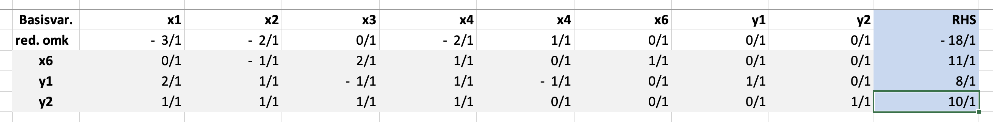
Vi tager x1 ind da den har lavest reducerde omkostninger
Ser
$$\frac{8}{2}<\frac{10}{1}$$
Da går y1 ud
Og vi pivoterer omkring 2 tallet i 1. søjle
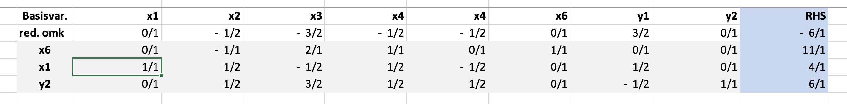
X3 har lavest reducerede omkostninger da går den ind i basis
Vi ser
$$\frac{11}{2}>\frac{12}{3}$$
Da går y2 ud og vi pivoterer omkring 3/2 i søjle 3
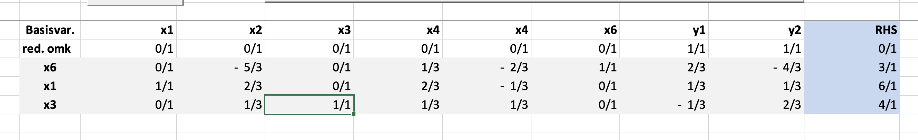
Denne løsning er optimal da $\overline{c}≥0$
Og da objektværdi=0 er problemet brugbar med en primalt brugbar startbasis
$$B=\{1,3,6\}$$
Vi retter tableauet til
$$A_{B}=\left(\begin{matrix}2 & -1 & 0 \\ 1 & 1 & 0 \\ 0 & 2 & 1\end{matrix}\right)$$
$$\overline{A}={\left(\begin{matrix}2 & -1 & 0 \\ 1 & 1 & 0 \\ 0 & 2 & 1\end{matrix}\right)}^{-1}\left(\begin{matrix}2 & 1 & -1 & 1 & -1 & 0 \\ 1 & 1 & 1 & 1 & 0 & 0 \\ 0 & -1 & 2 & 1 & 0 & 1\end{matrix}\right)=\left(\begin{matrix}1 & \frac{2}{3} & 0 & \frac{2}{3} & -\left(\frac{1}{3}\right) & 0 \\ 0 & \frac{1}{3} & 1 & \frac{1}{3} & \frac{1}{3} & 0 \\ 0 & -\left(\frac{5}{3}\right) & 0 & \frac{1}{3} & -\left(\frac{2}{3}\right) & 1\end{matrix}\right)$$
$$c_{B}=\left(\begin{matrix}3 & 3 & 0\end{matrix}\right)$$

$$\overline{c}=\left(\begin{matrix}3 & 4 & 3 & 5 & 0 & 0\end{matrix}\right)-\left(\begin{matrix}3 & 3 & 0\end{matrix}\right)\left(\begin{matrix}1 & \frac{2}{3} & 0 & \frac{2}{3} & -\left(\frac{1}{3}\right) & 0 \\ 0 & \frac{1}{3} & 1 & \frac{1}{3} & \frac{1}{3} & 0 \\ 0 & -\left(\frac{5}{3}\right) & 0 & \frac{1}{3} & -\left(\frac{2}{3}\right) & 1\end{matrix}\right)=\left(\begin{matrix}0 & 1 & 0 & 2 & 0 & 0\end{matrix}\right)$$
Da vi har maksimeringsproblem er vi ikke færdige

Vi regner objektværdi
$$6·3+4·3=30$$
Vi har tableauet
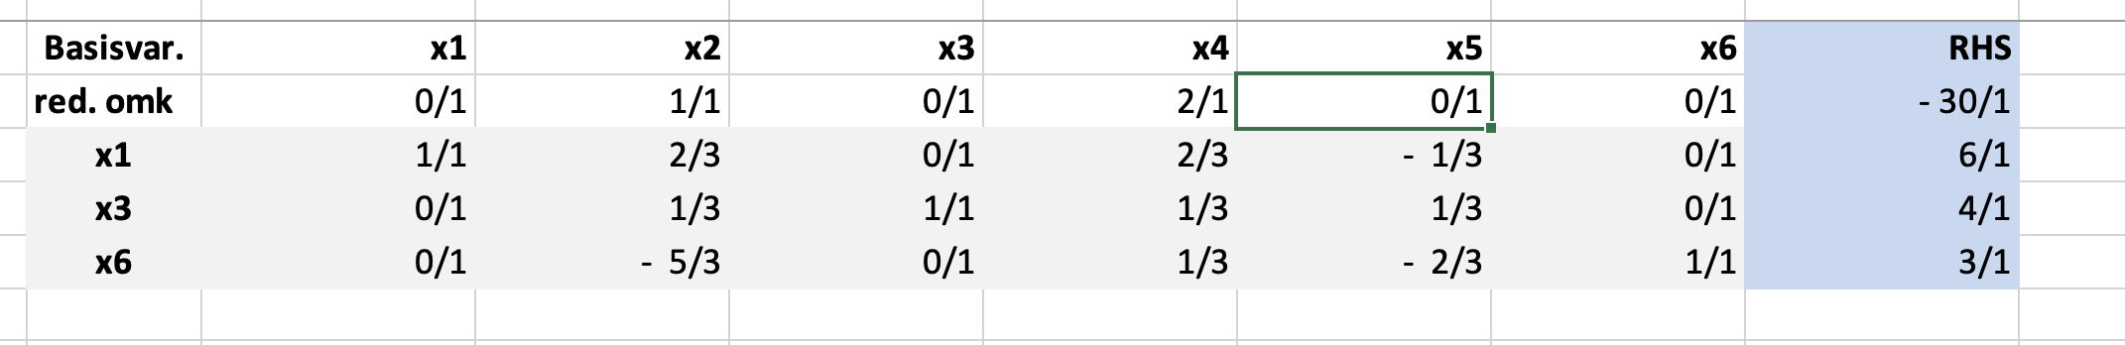
Vi ser at x4 skal ind og x6 går ind
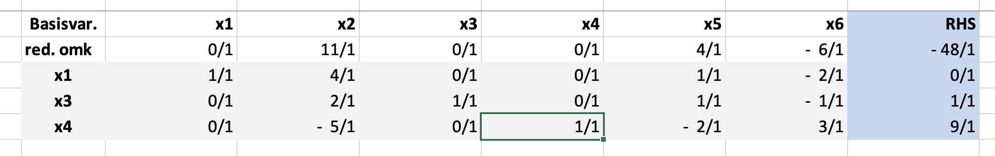

X2 går ind x1 går ud
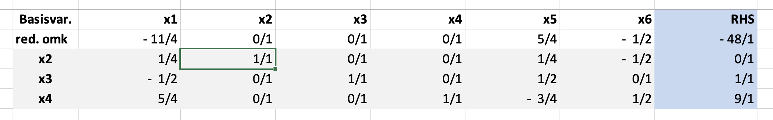
X5 går ind x2 går ud
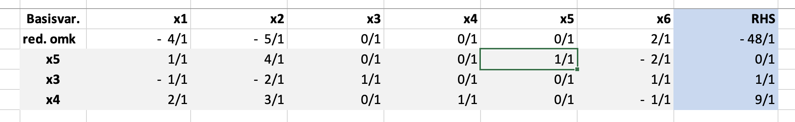
X6 går ind x3 går ud
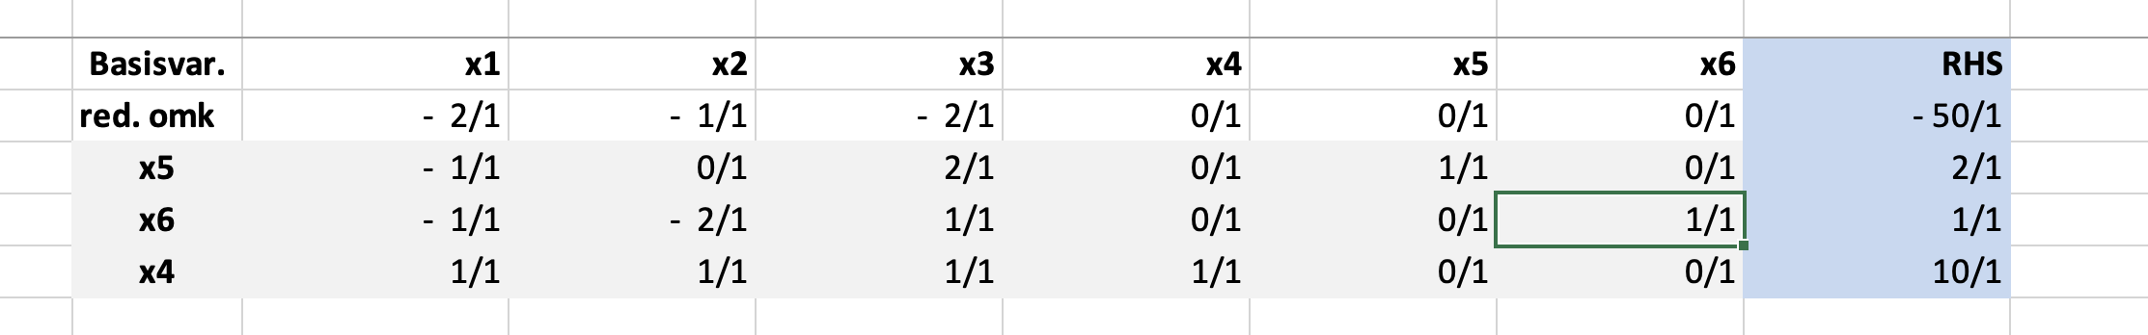
Nu optimal da $\overline{c}≤0$
Med objektværdi =50
Og $x^{⋆}=\left(\begin{aligned}0 \\ 0 \\ 0 \\ 10\end{aligned}\right)$
f)
ænding i objektværdi ændre ikke primal brugbarhed vi tjekker dual brugbarhed
$$A_{B}=\left(\begin{matrix}1 & -1 & 0 \\ 1 & 0 & 0 \\ 1 & 0 & 1\end{matrix}\right)$$
$$c=\left(\begin{matrix}3 & 4 & 12 & 5 & 0 & 0\end{matrix}\right)$$
$$\overline{c}=\left(\begin{matrix}3 & 4 & 12 & 5 & 0 & 0\end{matrix}\right)-\left(\begin{matrix}5 & 0 & 0\end{matrix}\right){\left(\begin{matrix}1 & -1 & 0 \\ 1 & 0 & 0 \\ 1 & 0 & 1\end{matrix}\right)}^{-1}\left(\begin{matrix}2 & 1 & -1 & 1 & -1 & 0 \\ 1 & 1 & 1 & 1 & 0 & 0 \\ 0 & -1 & 2 & 1 & 0 & 1\end{matrix}\right)=\left(\begin{matrix}-2 & -1 & 7 & 0 & 0 & 0\end{matrix}\right)$$
Ikke dualt brugbar da skal vi pivoterer
Vi skiver blot den nye $\overline{c}$ in i vores tableau
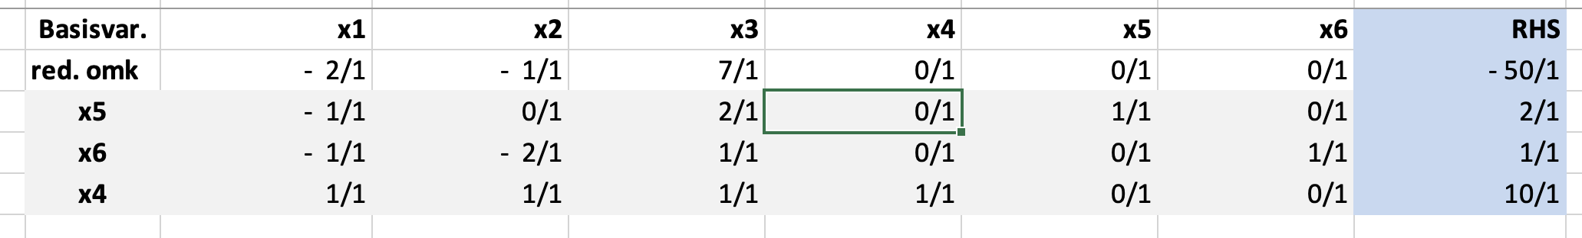
Vi ser at x3 går ind og enten x5 eller x6 går ud vi vælger at lade x6 gå ud
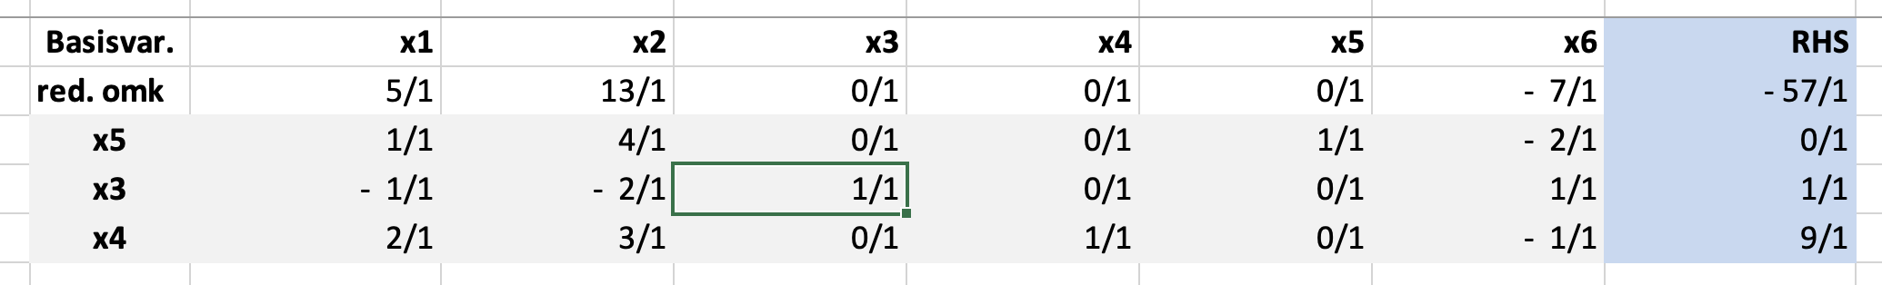

Opgave 2
P:
$$\min{c^{T}·f}$$
s.t $Af=b⇔\left(\begin{matrix}1 & 1 & 1 & 1 & 0 & 0 & 0 & 0 & 0 & 0 & 0 & 0 \\ 0 & 0 & 0 & 0 & 1 & 1 & 1 & 1 & 0 & 0 & 0 & 0 \\ 0 & 0 & 0 & 0 & 0 & 0 & 0 & 0 & 1 & 1 & 1 & 1 \\ 1 & 0 & 0 & 0 & 1 & 0 & 0 & 0 & 1 & 0 & 0 & 0 \\ 0 & 1 & 0 & 0 & 0 & 1 & 0 & 0 & 0 & 1 & 0 & 0 \\ 0 & 0 & 1 & 0 & 0 & 0 & 1 & 0 & 0 & 0 & 1 & 0 \\ 0 & 0 & 0 & 1 & 0 & 0 & 0 & 1 & 0 & 0 & 0 & 1\end{matrix}\right)\left(\begin{aligned}f_{1,1} \\ f_{1,2} \\ f_{1,3} \\ f_{1,4} \\ f_{2,1} \\ … \\ f_{3,4}\end{aligned}\right)=\left(\begin{aligned}250 \\ 300 \\ 400 \\ 200 \\ 225 \\ 275 \\ 250\end{aligned}\right)=b,f≥0$

D:
$$\max{b^{T}·\left(\begin{aligned}u \\ e\end{aligned}\right)}$$
$$s.t \left(\begin{matrix}1 & 0 & 0 & 1 & 0 & 0 & 0 \\ 1 & 0 & 0 & 0 & 1 & 0 & 0 \\ 1 & 0 & 0 & 0 & 0 & 1 & 0 \\ 1 & 0 & 0 & 0 & 0 & 0 & 1 \\ 0 & 1 & 0 & 1 & 0 & 0 & 0 \\ 0 & 1 & 0 & 0 & 1 & 0 & 0 \\ 0 & 1 & 0 & 0 & 0 & 1 & 0 \\ 0 & 1 & 0 & 0 & 0 & 0 & 1 \\ 0 & 0 & 1 & 1 & 0 & 0 & 0 \\ 0 & 0 & 1 & 0 & 1 & 0 & 0 \\ 0 & 0 & 1 & 0 & 0 & 1 & 0 \\ 0 & 0 & 1 & 0 & 0 & 0 & 1\end{matrix}\right)\left(\begin{aligned}u \\ e\end{aligned}\right)≤c$$
Med $b=\left(\begin{aligned}250 \\ 300 \\ 400 \\ 200 \\ 225 \\ 275 \\ 250\end{aligned}\right), c=\left(\begin{aligned}11 \\ 13 \\ 17 \\ 14 \\ 13 \\ 18 \\ 14 \\ 10 \\ 21 \\ 24 \\ 13 \\ 10\end{aligned}\right)$
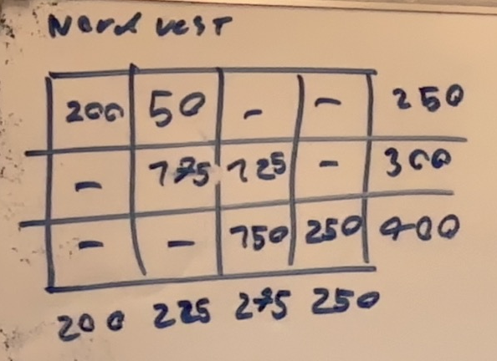
Vi finder nu den tilsvarende duale løsning
$$u_{1}+e_{1}=11$$
$$u_{1}+e_{2}=13$$
$$u_{2}+e_{2}=18$$
$$u_{2}+e_{3}=14$$
$$u_{3}+e_{3}=13$$
$$u_{3}+e_{4}=10$$
$$e_{4}=0$$
$⇕$ Ligningssystemet løses for u_1,e_1,e_2,u_2,e_3,u_3,e_4 vha. WordMat's 'Løs Ligninger' funktion,
$$u_{1}=6 ∧ e_{1}=5 ∧ e_{2}=7 ∧ u_{2}=11 ∧ e_{3}=3 ∧ u_{3}=10 ∧ e_{4}=0$$
$$\left(\begin{aligned}u \\ e\end{aligned}\right)=\left(\begin{aligned}6 \\ 11 \\ 10 \\ 5 \\ 7 \\ 3 \\ 0\end{aligned}\right)$$
Med
$$\overline{c}=c-A^{T}\left(\begin{aligned}u \\ e\end{aligned}\right)=\left(\begin{aligned}11 \\ 13 \\ 17 \\ 14 \\ 13 \\ 18 \\ 14 \\ 10 \\ 21 \\ 24 \\ 13 \\ 10\end{aligned}\right)-\left(\begin{matrix}1 & 0 & 0 & 1 & 0 & 0 & 0 \\ 1 & 0 & 0 & 0 & 1 & 0 & 0 \\ 1 & 0 & 0 & 0 & 0 & 1 & 0 \\ 1 & 0 & 0 & 0 & 0 & 0 & 1 \\ 0 & 1 & 0 & 1 & 0 & 0 & 0 \\ 0 & 1 & 0 & 0 & 1 & 0 & 0 \\ 0 & 1 & 0 & 0 & 0 & 1 & 0 \\ 0 & 1 & 0 & 0 & 0 & 0 & 1 \\ 0 & 0 & 1 & 1 & 0 & 0 & 0 \\ 0 & 0 & 1 & 0 & 1 & 0 & 0 \\ 0 & 0 & 1 & 0 & 0 & 1 & 0 \\ 0 & 0 & 1 & 0 & 0 & 0 & 1\end{matrix}\right)\left(\begin{aligned}6 \\ 11 \\ 10 \\ 5 \\ 7 \\ 3 \\ 0\end{aligned}\right)=\left(\begin{matrix}0 \\ 0 \\ 8 \\ 8 \\ -3 \\ 0 \\ 0 \\ -1 \\ 6 \\ 7 \\ 0 \\ 0\end{matrix}\right)$$

Vi ser at U2 til E1 har negative reducerede omkostninger da introduceres den til basis
Og vi pivoterer på skema
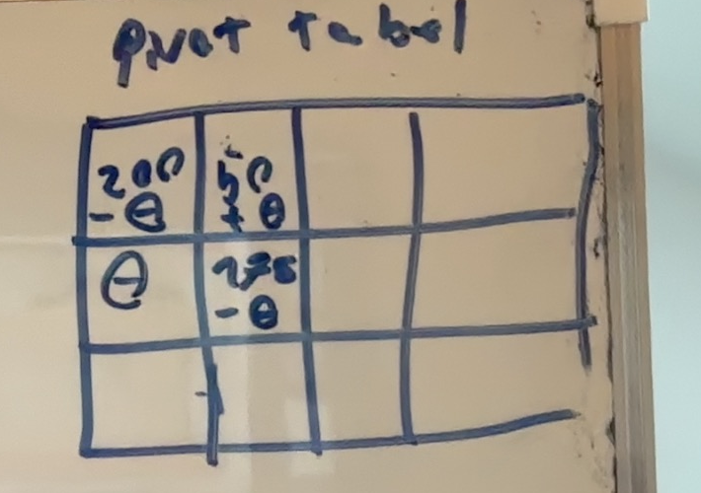
Vi ser at vi kan flowe 175 gennem og U2 til E2 går ud af basis
Dette giver os den nye løsning
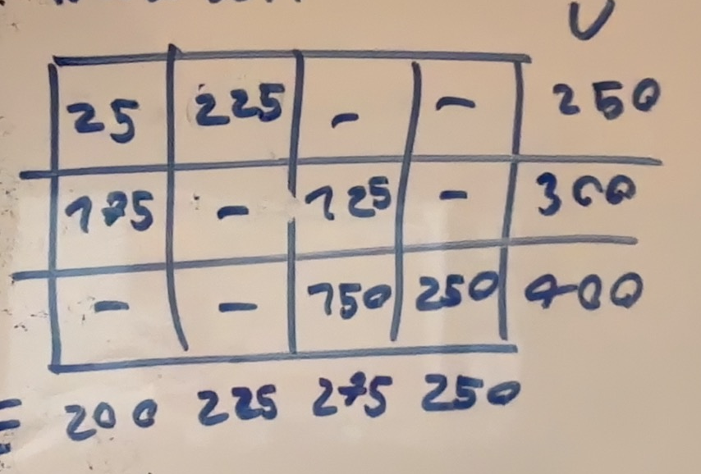
Igen regner vi de duale variable og de reducerede omkostninger

$$u_{1}+e_{1}=11$$
$$u_{1}+e_{2}=13$$
$$u_{2}+e_{1}=13$$
$$u_{2}+e_{3}=14$$
$$u_{3}+e_{3}=13$$
$$u_{3}+e_{4}=10$$
$$e_{4}=0$$
$⇕$ Ligningssystemet løses for u_1,e_1,e_2,u_2,e_3,u_3,e_4 vha. WordMat's 'Løs Ligninger' funktion,
$$u_{1}=9 ∧ e_{1}=2 ∧ e_{2}=4 ∧ u_{2}=11 ∧ e_{3}=3 ∧ u_{3}=10 ∧ e_{4}=0$$
$$\left(\begin{aligned}u \\ e\end{aligned}\right)=\left(\begin{aligned}9 \\ 11 \\ 10 \\ 2 \\ 4 \\ 3 \\ 0\end{aligned}\right)$$

$$\overline{c}=\left(\begin{aligned}11 \\ 13 \\ 17 \\ 14 \\ 13 \\ 18 \\ 14 \\ 10 \\ 21 \\ 24 \\ 13 \\ 10\end{aligned}\right)-\left(\begin{matrix}1 & 0 & 0 & 1 & 0 & 0 & 0 \\ 1 & 0 & 0 & 0 & 1 & 0 & 0 \\ 1 & 0 & 0 & 0 & 0 & 1 & 0 \\ 1 & 0 & 0 & 0 & 0 & 0 & 1 \\ 0 & 1 & 0 & 1 & 0 & 0 & 0 \\ 0 & 1 & 0 & 0 & 1 & 0 & 0 \\ 0 & 1 & 0 & 0 & 0 & 1 & 0 \\ 0 & 1 & 0 & 0 & 0 & 0 & 1 \\ 0 & 0 & 1 & 1 & 0 & 0 & 0 \\ 0 & 0 & 1 & 0 & 1 & 0 & 0 \\ 0 & 0 & 1 & 0 & 0 & 1 & 0 \\ 0 & 0 & 1 & 0 & 0 & 0 & 1\end{matrix}\right)\left(\begin{aligned}9 \\ 11 \\ 10 \\ 2 \\ 4 \\ 3 \\ 0\end{aligned}\right)=\left(\begin{matrix}0 \\ 0 \\ 5 \\ 5 \\ 0 \\ 3 \\ 0 \\ -1 \\ 9 \\ 10 \\ 0 \\ 0\end{matrix}\right)$$
Vi ser der er reducerede omkostninger ved at introducere
U2 til E4
Igen kører vi pivotering på skema
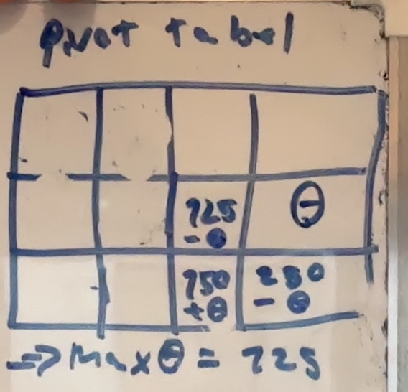
Da flower vi 125 og U2 til E3 går ud af basis
Ny løsning:
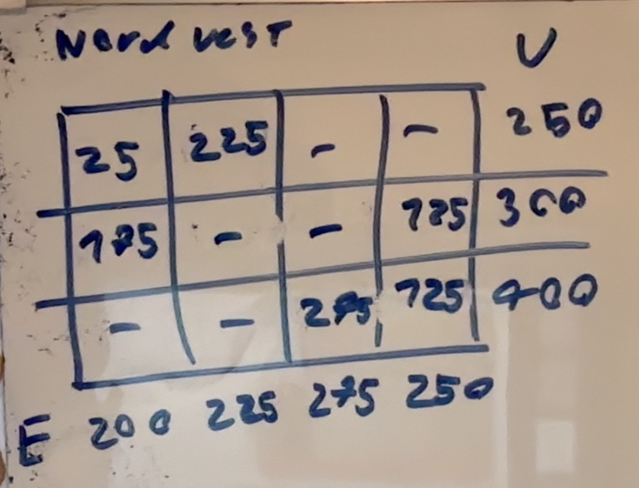
Ignorer toppen hvor der står nordvest
Vi regner igen de reducerede omkostninger

$$u_{1}+e_{1}=11$$
$$u_{1}+e_{2}=13$$
$$u_{2}+e_{1}=13$$
$$u_{2}+e_{4}=10$$
$$u_{3}+e_{3}=13$$
$$u_{3}+e_{4}=10$$
$$e_{4}=0$$
$⇕$ Ligningssystemet løses for u_1,e_1,e_2,u_2,e_4,u_3,e_3 vha. WordMat's 'Løs Ligninger' funktion,
$$u_{1}=8 ∧ e_{1}=3 ∧ e_{2}=5 ∧ u_{2}=10 ∧ e_{4}=0 ∧ u_{3}=10 ∧ e_{3}=3$$
$$\left(\begin{aligned}u \\ e\end{aligned}\right)=\left(\begin{aligned}8 \\ 10 \\ 10 \\ 3 \\ 5 \\ 3 \\ 0\end{aligned}\right)$$
$$\overline{c}=\left(\begin{aligned}11 \\ 13 \\ 17 \\ 14 \\ 13 \\ 18 \\ 14 \\ 10 \\ 21 \\ 24 \\ 13 \\ 10\end{aligned}\right)-\left(\begin{matrix}1 & 0 & 0 & 1 & 0 & 0 & 0 \\ 1 & 0 & 0 & 0 & 1 & 0 & 0 \\ 1 & 0 & 0 & 0 & 0 & 1 & 0 \\ 1 & 0 & 0 & 0 & 0 & 0 & 1 \\ 0 & 1 & 0 & 1 & 0 & 0 & 0 \\ 0 & 1 & 0 & 0 & 1 & 0 & 0 \\ 0 & 1 & 0 & 0 & 0 & 1 & 0 \\ 0 & 1 & 0 & 0 & 0 & 0 & 1 \\ 0 & 0 & 1 & 1 & 0 & 0 & 0 \\ 0 & 0 & 1 & 0 & 1 & 0 & 0 \\ 0 & 0 & 1 & 0 & 0 & 1 & 0 \\ 0 & 0 & 1 & 0 & 0 & 0 & 1\end{matrix}\right)\left(\begin{aligned}8 \\ 10 \\ 10 \\ 3 \\ 5 \\ 3 \\ 0\end{aligned}\right)=\left(\begin{matrix}0 \\ 0 \\ 6 \\ 6 \\ 0 \\ 3 \\ 1 \\ 0 \\ 8 \\ 9 \\ 0 \\ 0\end{matrix}\right)≥0$$
Da er løsningen optimal
Med objektværdi
$$25·11+225·13+175·13+125·10+275·13+125·10=11550$$
d)
vi ved per følsomhedsanalyse at en ænding i objektværdi ikke ændre på primal brugbarhed da skal vi blot tjekke dualt brugbarhed for at finde ud af om basis stadig er optimal
vi ser at f_2,3 ikke var en del af vores optimale løsning da ændres de duale variable ikke kun omkostningen på den
vi ændre omkostningsvektoren

$$\left(\begin{aligned}11 \\ 13 \\ 17 \\ 14 \\ 13 \\ 18 \\ 11 \\ 10 \\ 21 \\ 24 \\ 13 \\ 10\end{aligned}\right)-\left(\begin{matrix}1 & 0 & 0 & 1 & 0 & 0 & 0 \\ 1 & 0 & 0 & 0 & 1 & 0 & 0 \\ 1 & 0 & 0 & 0 & 0 & 1 & 0 \\ 1 & 0 & 0 & 0 & 0 & 0 & 1 \\ 0 & 1 & 0 & 1 & 0 & 0 & 0 \\ 0 & 1 & 0 & 0 & 1 & 0 & 0 \\ 0 & 1 & 0 & 0 & 0 & 1 & 0 \\ 0 & 1 & 0 & 0 & 0 & 0 & 1 \\ 0 & 0 & 1 & 1 & 0 & 0 & 0 \\ 0 & 0 & 1 & 0 & 1 & 0 & 0 \\ 0 & 0 & 1 & 0 & 0 & 1 & 0 \\ 0 & 0 & 1 & 0 & 0 & 0 & 1\end{matrix}\right)\left(\begin{aligned}8 \\ 10 \\ 10 \\ 3 \\ 5 \\ 3 \\ 0\end{aligned}\right)=\left(\begin{matrix}0 \\ 0 \\ 6 \\ 6 \\ 0 \\ 3 \\ -2 \\ 0 \\ 8 \\ 9 \\ 0 \\ 0\end{matrix}\right)$$
Ikke optimal
U2 til E3 går ind noget siger mig at vi bare skal pivoterer tilbage til løsningen et skridt fra optimalitet i opgaven før så den prøver vi
Vi regner de reducerede omkostninger med den nye omkostning

$$u_{1}+e_{1}=11$$
$$u_{1}+e_{2}=13$$
$$u_{2}+e_{1}=13$$
$$u_{2}+e_{3}=11$$
$$u_{3}+e_{3}=13$$
$$u_{3}+e_{4}=10$$
$$e_{4}=0$$
$⇕$ Ligningssystemet løses for u_1,e_1,e_2,u_2,e_3,u_3,e_4 vha. WordMat's 'Løs Ligninger' funktion,
$$u_{1}=6 ∧ e_{1}=5 ∧ e_{2}=7 ∧ u_{2}=8 ∧ e_{3}=3 ∧ u_{3}=10 ∧ e_{4}=0$$
$$\left(\begin{aligned}u \\ e\end{aligned}\right)=\left(\begin{aligned}6 \\ 8 \\ 10 \\ 5 \\ 7 \\ 3 \\ 0\end{aligned}\right)\left(\begin{aligned}11 \\ 13 \\ 17 \\ 14 \\ 13 \\ 18 \\ 11 \\ 10 \\ 21 \\ 24 \\ 13 \\ 10\end{aligned}\right)-\left(\begin{matrix}1 & 0 & 0 & 1 & 0 & 0 & 0 \\ 1 & 0 & 0 & 0 & 1 & 0 & 0 \\ 1 & 0 & 0 & 0 & 0 & 1 & 0 \\ 1 & 0 & 0 & 0 & 0 & 0 & 1 \\ 0 & 1 & 0 & 1 & 0 & 0 & 0 \\ 0 & 1 & 0 & 0 & 1 & 0 & 0 \\ 0 & 1 & 0 & 0 & 0 & 1 & 0 \\ 0 & 1 & 0 & 0 & 0 & 0 & 1 \\ 0 & 0 & 1 & 1 & 0 & 0 & 0 \\ 0 & 0 & 1 & 0 & 1 & 0 & 0 \\ 0 & 0 & 1 & 0 & 0 & 1 & 0 \\ 0 & 0 & 1 & 0 & 0 & 0 & 1\end{matrix}\right)\left(\begin{aligned}6 \\ 8 \\ 10 \\ 5 \\ 7 \\ 3 \\ 0\end{aligned}\right)=\left(\begin{matrix}0 \\ 0 \\ 8 \\ 8 \\ 0 \\ 3 \\ 0 \\ 2 \\ 6 \\ 7 \\ 0 \\ 0\end{matrix}\right)≥0$$
Da er denne løsning opimal for den nye omkostning

e)
vi ostiller som lineært problem og finder de reducerede omkostninger
$$b=\left(\begin{aligned}1 \\ 1 \\ 1 \\ 1 \\ 1 \\ 1 \\ 1 \\ 1\end{aligned}\right)$$
$$c=\left(\begin{aligned}8 \\ 26 \\ 17 \\ 11 \\ 13 \\ 28 \\ 4 \\ 26 \\ 38 \\ 19 \\ 18 \\ 15 \\ 19 \\ 26 \\ 24 \\ 10\end{aligned}\right)$$
Vi tager løsningen givet og tager nogle tilfældige variable med
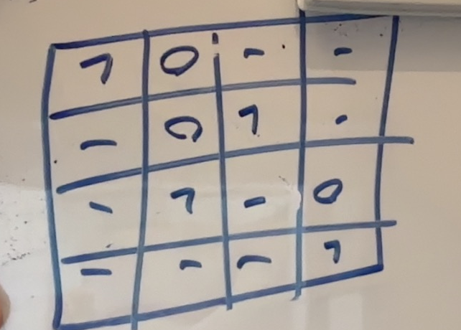
Vi regner de duale variable og reducerede omkostninger
$$u_{1}+e_{1}=8$$
$$u_{1}+e_{2}=26$$
$$u_{2}+e_{2}=28$$
$$u_{2}+e_{3}=4$$
$$u_{3}+e_{2}=19$$
$$u_{3}+e_{4}=15$$
$$u_{4}+e_{4}=10$$
$$e_{4}=0$$
$⇕$ Ligningssystemet løses for u_1,e_1,e_2,u_2,e_3,u_3,e_4,u_4 vha. WordMat's 'Løs Ligninger' funktion,
$$u_{1}=22 ∧ e_{1}=-14 ∧ e_{2}=4 ∧ u_{2}=24 ∧ e_{3}=-20 ∧ u_{3}=15 ∧ e_{4}=0 ∧ u_{4}=10$$
$$\left(\begin{aligned}u \\ e\end{aligned}\right)=\left(\begin{aligned}22 \\ 24 \\ 15 \\ 10 \\ -14 \\ 4 \\ -20 \\ 0\end{aligned}\right)$$
$$\left(\begin{aligned}8 \\ 26 \\ 17 \\ 11 \\ 13 \\ 28 \\ 4 \\ 26 \\ 38 \\ 19 \\ 18 \\ 15 \\ 19 \\ 26 \\ 24 \\ 10\end{aligned}\right)-\left(\begin{matrix}1 & 0 & 0 & 0 & 1 & 0 & 0 & 0 \\ 1 & 0 & 0 & 0 & 0 & 1 & 0 & 0 \\ 1 & 0 & 0 & 0 & 0 & 0 & 1 & 0 \\ 1 & 0 & 0 & 0 & 0 & 0 & 0 & 1 \\ 0 & 1 & 0 & 0 & 1 & 0 & 0 & 0 \\ 0 & 1 & 0 & 0 & 0 & 1 & 0 & 0 \\ 0 & 1 & 0 & 0 & 0 & 0 & 1 & 0 \\ 0 & 1 & 0 & 0 & 0 & 0 & 0 & 1 \\ 0 & 0 & 1 & 0 & 1 & 0 & 0 & 0 \\ 0 & 0 & 1 & 0 & 0 & 1 & 0 & 0 \\ 0 & 0 & 1 & 0 & 0 & 0 & 1 & 0 \\ 0 & 0 & 1 & 0 & 0 & 0 & 0 & 1 \\ 0 & 0 & 0 & 1 & 1 & 0 & 0 & 0 \\ 0 & 0 & 0 & 1 & 0 & 1 & 0 & 0 \\ 0 & 0 & 0 & 1 & 0 & 0 & 1 & 0 \\ 0 & 0 & 0 & 1 & 0 & 0 & 0 & 1\end{matrix}\right)\left(\begin{aligned}22 \\ 24 \\ 15 \\ 10 \\ -14 \\ 4 \\ -20 \\ 0\end{aligned}\right)=\left(\begin{matrix}0 \\ 0 \\ 15 \\ -11 \\ 3 \\ 0 \\ 0 \\ 2 \\ 37 \\ 0 \\ 23 \\ 0 \\ 23 \\ 12 \\ 34 \\ 0\end{matrix}\right)$$
Vi skal lige pivoterer en gang eller 2 så den duale løsning er glad
Vi tager 1 til 4 ind og smider 1 til 2 ud vi kan ikke flowe noget igennem så løsningen ændres ikke
$$u_{1}+e_{1}=8$$
$$u_{1}+e_{4}=11$$
$$u_{2}+e_{2}=28$$
$$u_{2}+e_{3}=4$$
$$u_{3}+e_{2}=19$$
$$u_{3}+e_{4}=15$$
$$u_{4}+e_{4}=10$$
$$e_{4}=0$$
$⇕$ Ligningssystemet løses for u_1,e_1,e_4,u_2,e_2,e_3,u_3,u_4 vha. WordMat's 'Løs Ligninger' funktion,
$$u_{1}=11 ∧ e_{1}=-3 ∧ e_{4}=0 ∧ u_{2}=24 ∧ e_{2}=4 ∧ e_{3}=-20 ∧ u_{3}=15 ∧ u_{4}=10$$
$$\left(\begin{aligned}u \\ e\end{aligned}\right)=\left(\begin{aligned}11 \\ 24 \\ 15 \\ 10 \\ -3 \\ 4 \\ -20 \\ 0\end{aligned}\right)$$

$$\left(\begin{aligned}8 \\ 26 \\ 17 \\ 11 \\ 13 \\ 28 \\ 4 \\ 26 \\ 38 \\ 19 \\ 18 \\ 15 \\ 19 \\ 26 \\ 24 \\ 10\end{aligned}\right)-\left(\begin{matrix}1 & 0 & 0 & 0 & 1 & 0 & 0 & 0 \\ 1 & 0 & 0 & 0 & 0 & 1 & 0 & 0 \\ 1 & 0 & 0 & 0 & 0 & 0 & 1 & 0 \\ 1 & 0 & 0 & 0 & 0 & 0 & 0 & 1 \\ 0 & 1 & 0 & 0 & 1 & 0 & 0 & 0 \\ 0 & 1 & 0 & 0 & 0 & 1 & 0 & 0 \\ 0 & 1 & 0 & 0 & 0 & 0 & 1 & 0 \\ 0 & 1 & 0 & 0 & 0 & 0 & 0 & 1 \\ 0 & 0 & 1 & 0 & 1 & 0 & 0 & 0 \\ 0 & 0 & 1 & 0 & 0 & 1 & 0 & 0 \\ 0 & 0 & 1 & 0 & 0 & 0 & 1 & 0 \\ 0 & 0 & 1 & 0 & 0 & 0 & 0 & 1 \\ 0 & 0 & 0 & 1 & 1 & 0 & 0 & 0 \\ 0 & 0 & 0 & 1 & 0 & 1 & 0 & 0 \\ 0 & 0 & 0 & 1 & 0 & 0 & 1 & 0 \\ 0 & 0 & 0 & 1 & 0 & 0 & 0 & 1\end{matrix}\right)\left(\begin{aligned}11 \\ 24 \\ 15 \\ 10 \\ -3 \\ 4 \\ -20 \\ 0\end{aligned}\right)=\left(\begin{matrix}0 \\ 11 \\ 26 \\ 0 \\ -8 \\ 0 \\ 0 \\ 2 \\ 26 \\ 0 \\ 23 \\ 0 \\ 12 \\ 12 \\ 34 \\ 0\end{matrix}\right)$$
Igen lader vi 2,1 gi ind og smider 2,2 ud og flower ingenting da vi rammer et 0
$$u_{1}+e_{1}=8$$
$$u_{1}+e_{4}=11$$
$$u_{2}+e_{1}=13$$
$$u_{2}+e_{3}=4$$
$$u_{3}+e_{2}=19$$
$$u_{3}+e_{4}=15$$
$$u_{4}+e_{4}=10$$
$$e_{4}=0$$
$⇕$ Ligningssystemet løses for u_1,e_1,e_4,u_2,e_3,u_3,e_2,u_4 vha. WordMat's 'Løs Ligninger' funktion,
$$u_{1}=11 ∧ e_{1}=-3 ∧ e_{4}=0 ∧ u_{2}=16 ∧ e_{3}=-12 ∧ u_{3}=15 ∧ e_{2}=4 ∧ u_{4}=10$$
$$\left(\begin{aligned}u \\ e\end{aligned}\right)=\left(\begin{aligned}11 \\ 16 \\ 15 \\ 10 \\ -3 \\ 4 \\ -12 \\ 0\end{aligned}\right)$$
$$\left(\begin{aligned}8 \\ 26 \\ 17 \\ 11 \\ 13 \\ 28 \\ 4 \\ 26 \\ 38 \\ 19 \\ 18 \\ 15 \\ 19 \\ 26 \\ 24 \\ 10\end{aligned}\right)-\left(\begin{matrix}1 & 0 & 0 & 0 & 1 & 0 & 0 & 0 \\ 1 & 0 & 0 & 0 & 0 & 1 & 0 & 0 \\ 1 & 0 & 0 & 0 & 0 & 0 & 1 & 0 \\ 1 & 0 & 0 & 0 & 0 & 0 & 0 & 1 \\ 0 & 1 & 0 & 0 & 1 & 0 & 0 & 0 \\ 0 & 1 & 0 & 0 & 0 & 1 & 0 & 0 \\ 0 & 1 & 0 & 0 & 0 & 0 & 1 & 0 \\ 0 & 1 & 0 & 0 & 0 & 0 & 0 & 1 \\ 0 & 0 & 1 & 0 & 1 & 0 & 0 & 0 \\ 0 & 0 & 1 & 0 & 0 & 1 & 0 & 0 \\ 0 & 0 & 1 & 0 & 0 & 0 & 1 & 0 \\ 0 & 0 & 1 & 0 & 0 & 0 & 0 & 1 \\ 0 & 0 & 0 & 1 & 1 & 0 & 0 & 0 \\ 0 & 0 & 0 & 1 & 0 & 1 & 0 & 0 \\ 0 & 0 & 0 & 1 & 0 & 0 & 1 & 0 \\ 0 & 0 & 0 & 1 & 0 & 0 & 0 & 1\end{matrix}\right)\left(\begin{aligned}11 \\ 16 \\ 15 \\ 10 \\ -3 \\ 4 \\ -12 \\ 0\end{aligned}\right)=\left(\begin{matrix}0 \\ 11 \\ 18 \\ 0 \\ 0 \\ 8 \\ 0 \\ 10 \\ 26 \\ 0 \\ 15 \\ 0 \\ 12 \\ 12 \\ 26 \\ 0\end{matrix}\right)≥0$$
Da er løsningen optimal

f)
vi sætter et $α$ i stedet for 38
og tjekker hvornår denne løsning stadig er optimal
$$\left(\begin{aligned}8 \\ 26 \\ 17 \\ 11 \\ 13 \\ 28 \\ 4 \\ 26 \\ α \\ 19 \\ 18 \\ 15 \\ 19 \\ 26 \\ 24 \\ 10\end{aligned}\right)-\left(\begin{matrix}1 & 0 & 0 & 0 & 1 & 0 & 0 & 0 \\ 1 & 0 & 0 & 0 & 0 & 1 & 0 & 0 \\ 1 & 0 & 0 & 0 & 0 & 0 & 1 & 0 \\ 1 & 0 & 0 & 0 & 0 & 0 & 0 & 1 \\ 0 & 1 & 0 & 0 & 1 & 0 & 0 & 0 \\ 0 & 1 & 0 & 0 & 0 & 1 & 0 & 0 \\ 0 & 1 & 0 & 0 & 0 & 0 & 1 & 0 \\ 0 & 1 & 0 & 0 & 0 & 0 & 0 & 1 \\ 0 & 0 & 1 & 0 & 1 & 0 & 0 & 0 \\ 0 & 0 & 1 & 0 & 0 & 1 & 0 & 0 \\ 0 & 0 & 1 & 0 & 0 & 0 & 1 & 0 \\ 0 & 0 & 1 & 0 & 0 & 0 & 0 & 1 \\ 0 & 0 & 0 & 1 & 1 & 0 & 0 & 0 \\ 0 & 0 & 0 & 1 & 0 & 1 & 0 & 0 \\ 0 & 0 & 0 & 1 & 0 & 0 & 1 & 0 \\ 0 & 0 & 0 & 1 & 0 & 0 & 0 & 1\end{matrix}\right)\left(\begin{aligned}11 \\ 16 \\ 15 \\ 10 \\ -3 \\ 4 \\ -12 \\ 0\end{aligned}\right)=\left(\begin{matrix}0 \\ 11 \\ 18 \\ 0 \\ 0 \\ 8 \\ 0 \\ 10 \\ α-12 \\ 0 \\ 15 \\ 0 \\ 12 \\ 12 \\ 26 \\ 0\end{matrix}\right)$$
Den originale løsning er optimal for $α≥12$
Hvis $α<12$ pivoterer vi den ind
Vi ser 3,1 skal ind og 3,4 skal ud

$$u_{1}+e_{1}=8$$
$$u_{1}+e_{4}=11$$
$$u_{2}+e_{1}=13$$
$$u_{2}+e_{3}=4$$
$$u_{3}+e_{2}=19$$
$$u_{3}+e_{1}=α$$
$$u_{4}+e_{4}=10$$
$$e_{4}=0$$

$$\left(\begin{aligned}u \\ e\end{aligned}\right)=\left(\begin{aligned}11 \\ 16 \\ 3+α \\ 10 \\ -3 \\ 16-α \\ -12 \\ 0\end{aligned}\right)$$
$$\left(\begin{aligned}8 \\ 26 \\ 17 \\ 11 \\ 13 \\ 28 \\ 4 \\ 26 \\ α \\ 19 \\ 18 \\ 15 \\ 19 \\ 26 \\ 24 \\ 10\end{aligned}\right)-\left(\begin{matrix}1 & 0 & 0 & 0 & 1 & 0 & 0 & 0 \\ 1 & 0 & 0 & 0 & 0 & 1 & 0 & 0 \\ 1 & 0 & 0 & 0 & 0 & 0 & 1 & 0 \\ 1 & 0 & 0 & 0 & 0 & 0 & 0 & 1 \\ 0 & 1 & 0 & 0 & 1 & 0 & 0 & 0 \\ 0 & 1 & 0 & 0 & 0 & 1 & 0 & 0 \\ 0 & 1 & 0 & 0 & 0 & 0 & 1 & 0 \\ 0 & 1 & 0 & 0 & 0 & 0 & 0 & 1 \\ 0 & 0 & 1 & 0 & 1 & 0 & 0 & 0 \\ 0 & 0 & 1 & 0 & 0 & 1 & 0 & 0 \\ 0 & 0 & 1 & 0 & 0 & 0 & 1 & 0 \\ 0 & 0 & 1 & 0 & 0 & 0 & 0 & 1 \\ 0 & 0 & 0 & 1 & 1 & 0 & 0 & 0 \\ 0 & 0 & 0 & 1 & 0 & 1 & 0 & 0 \\ 0 & 0 & 0 & 1 & 0 & 0 & 1 & 0 \\ 0 & 0 & 0 & 1 & 0 & 0 & 0 & 1\end{matrix}\right)\left(\begin{aligned}11 \\ 16 \\ 3+α \\ 10 \\ -3 \\ 16-α \\ -12 \\ 0\end{aligned}\right)=\left(\begin{matrix}0 \\ α-1 \\ 18 \\ 0 \\ 0 \\ α-4 \\ 0 \\ 10 \\ 0 \\ 0 \\ 27-α \\ 12-α \\ 12 \\ α \\ 26 \\ 0\end{matrix}\right)$$
Da er løsningen stadig optimal

